# 20210716
# Documentations.
#
# "(SORM3) Проблемы при отправке файлов",
# "4.1.1 SORM"

*. Задача SD "(СОРМ) Не отправлены 15-ти минутные файлы" (https://forge.tcsbank.ru/case/5705094/info). Решил задачу. Пришлось ещё в Слаке попереписываться с Димой Сорокиным.
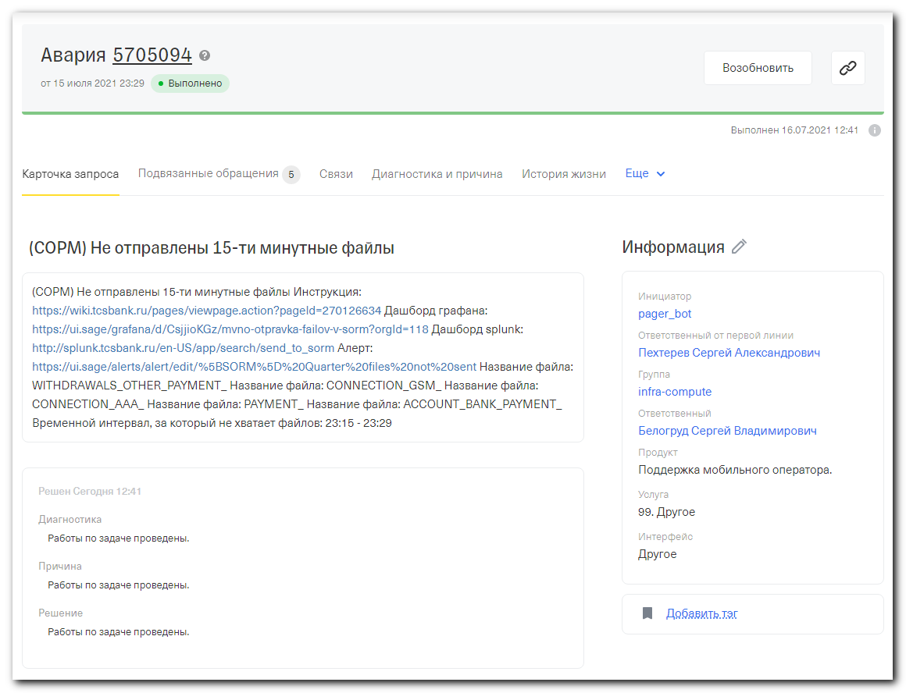
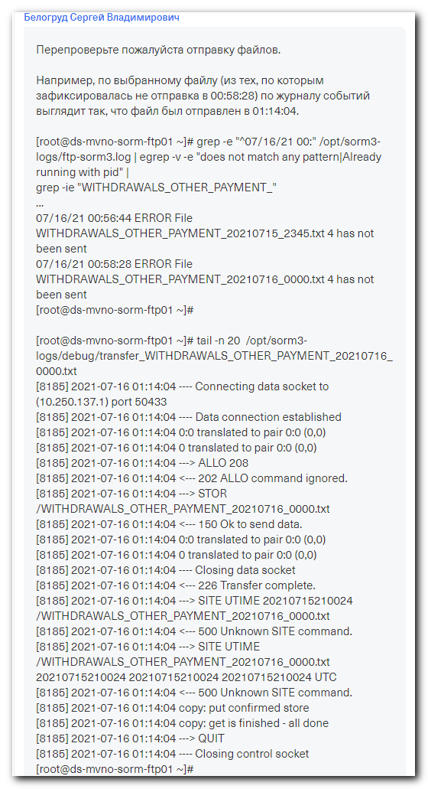
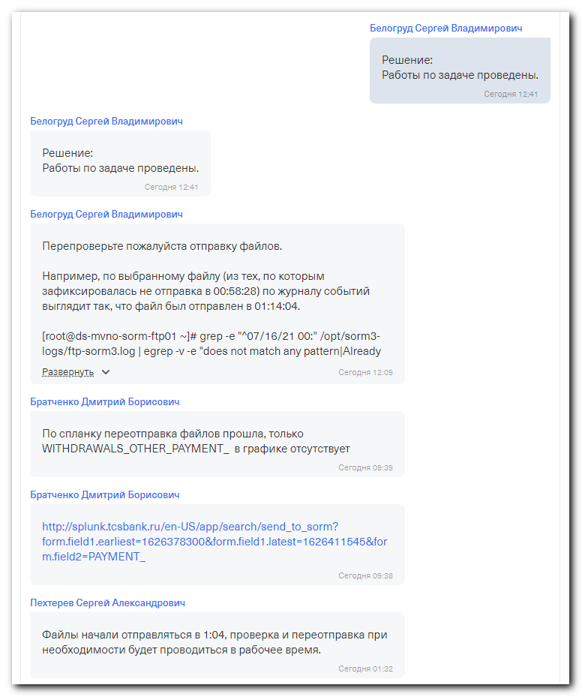
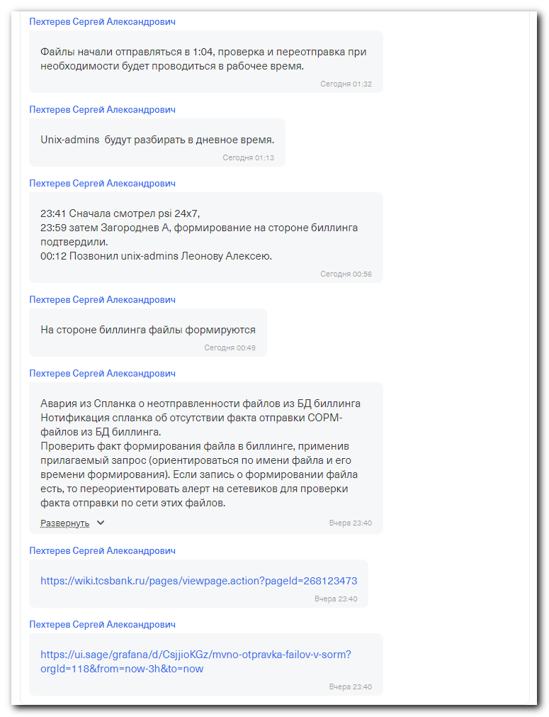

Перепроверьте пожалуйста отправку файлов.

Например, по выбранному файлу (из тех, по которым зафиксировалась не отправка в 00:58:28) по журналу событий выглядит так, что файл был отправлен в 01:14:04.

[root@ds-mvno-sorm-ftp01 ~]# grep -e "^07/16/21 00:" /opt/sorm3-logs/ftp-sorm3.log | egrep -v -e "does not match any pattern|Already running with pid" |
grep -ie "WITHDRAWALS_OTHER_PAYMENT_"
...
07/16/21 00:56:44 ERROR File WITHDRAWALS_OTHER_PAYMENT_20210715_2345.txt 4 has not been sent
07/16/21 00:58:28 ERROR File WITHDRAWALS_OTHER_PAYMENT_20210716_0000.txt 4 has not been sent
[root@ds-mvno-sorm-ftp01 ~]#

[root@ds-mvno-sorm-ftp01 ~]# tail -n 20 /opt/sorm3-logs/debug/transfer_WITHDRAWALS_OTHER_PAYMENT_20210716_0000.txt
[8185] 2021-07-16 01:14:04 ---- Connecting data socket to (10.250.137.1) port 50433
[8185] 2021-07-16 01:14:04 ---- Data connection established
[8185] 2021-07-16 01:14:04 0:0 translated to pair 0:0 (0,0)
[8185] 2021-07-16 01:14:04 0 translated to pair 0:0 (0,0)
[8185] 2021-07-16 01:14:04 ---> ALLO 208
[8185] 2021-07-16 01:14:04 <--- 202 ALLO command ignored.
[8185] 2021-07-16 01:14:04 ---> STOR /WITHDRAWALS_OTHER_PAYMENT_20210716_0000.txt
[8185] 2021-07-16 01:14:04 <--- 150 Ok to send data.
[8185] 2021-07-16 01:14:04 0:0 translated to pair 0:0 (0,0)
[8185] 2021-07-16 01:14:04 0 translated to pair 0:0 (0,0)
[8185] 2021-07-16 01:14:04 ---- Closing data socket
[8185] 2021-07-16 01:14:04 <--- 226 Transfer complete.
[8185] 2021-07-16 01:14:04 ---> SITE UTIME 20210715210024 /WITHDRAWALS_OTHER_PAYMENT_20210716_0000.txt
[8185] 2021-07-16 01:14:04 <--- 500 Unknown SITE command.
[8185] 2021-07-16 01:14:04 ---> SITE UTIME /WITHDRAWALS_OTHER_PAYMENT_20210716_0000.txt 20210715210024 20210715210024 20210715210024 UTC
[8185] 2021-07-16 01:14:04 <--- 500 Unknown SITE command.
[8185] 2021-07-16 01:14:04 copy: put confirmed store
[8185] 2021-07-16 01:14:04 copy: get is finished - all done
[8185] 2021-07-16 01:14:04 ---> QUIT
[8185] 2021-07-16 01:14:04 ---- Closing control socket
[root@ds-mvno-sorm-ftp01 ~]#

https://tinkoff.slack.com/archives/CTRAME9LP/p1626425226077200
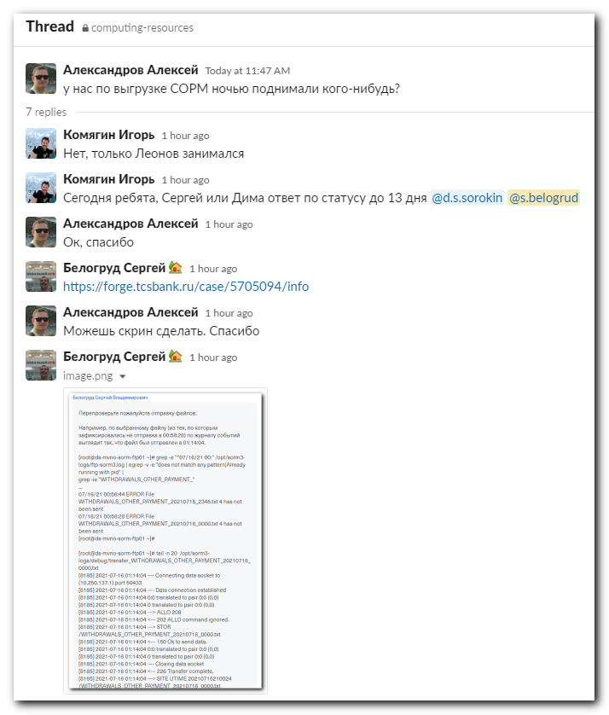
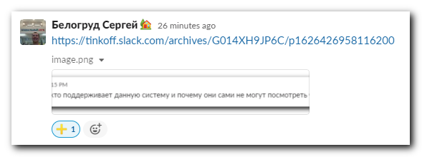

https://tinkoff.slack.com/archives/G014XH9JP6C/p1626426958116200
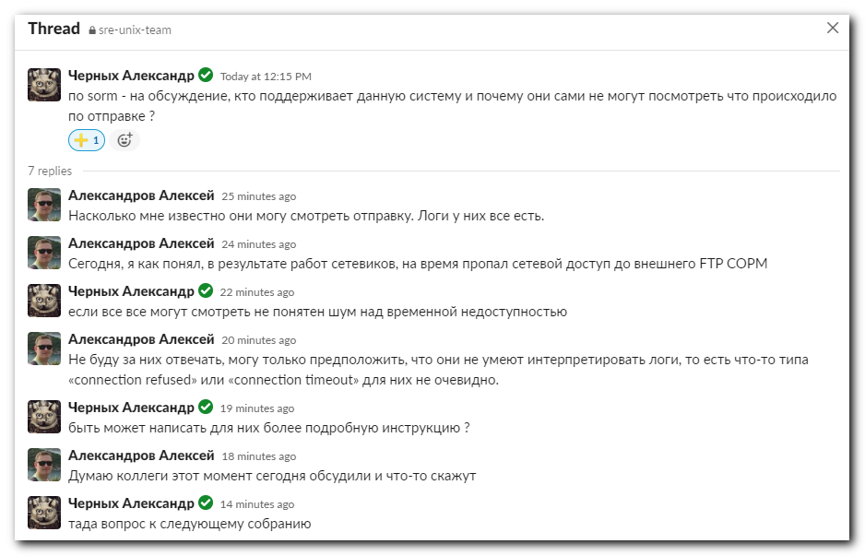

https://tinkoff.slack.com/archives/D015M99KR5L/p1624879171012400
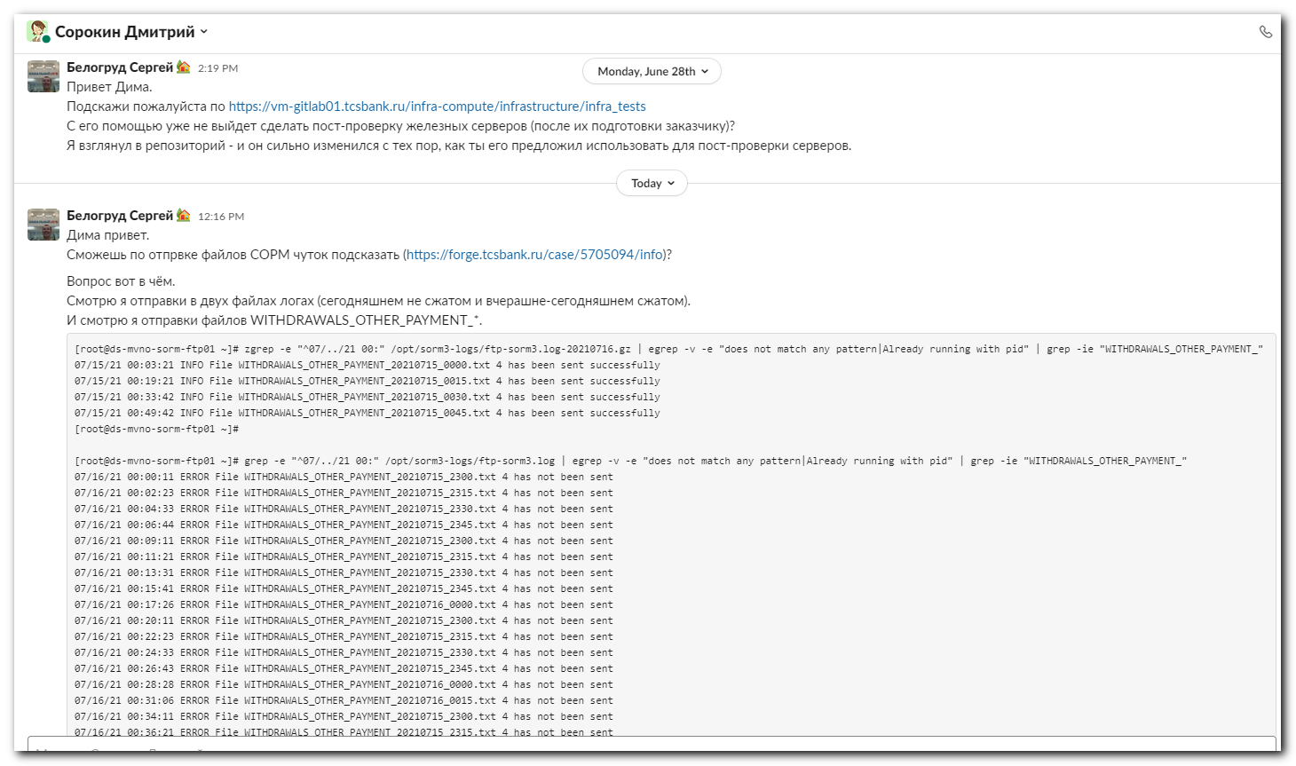
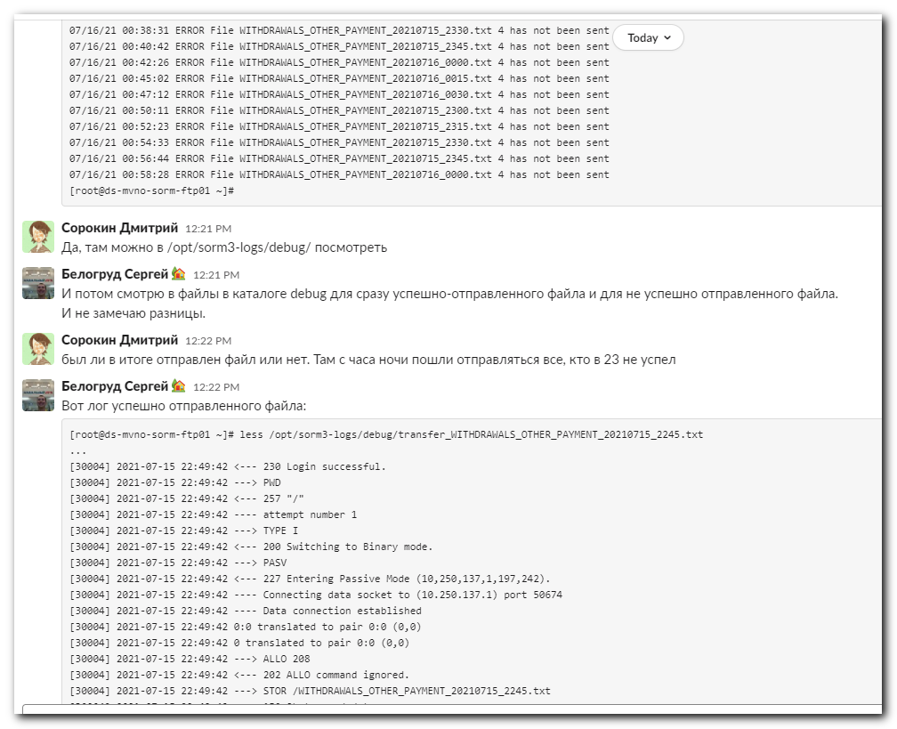
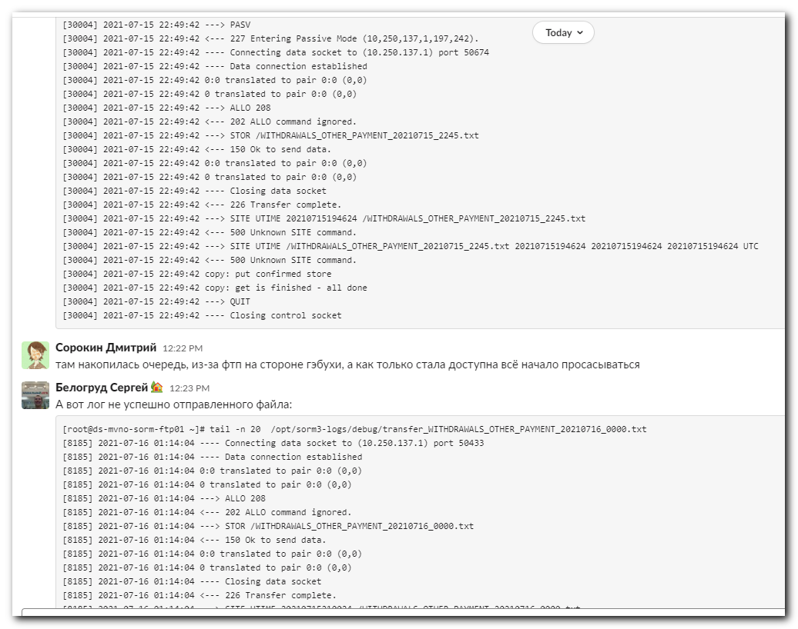
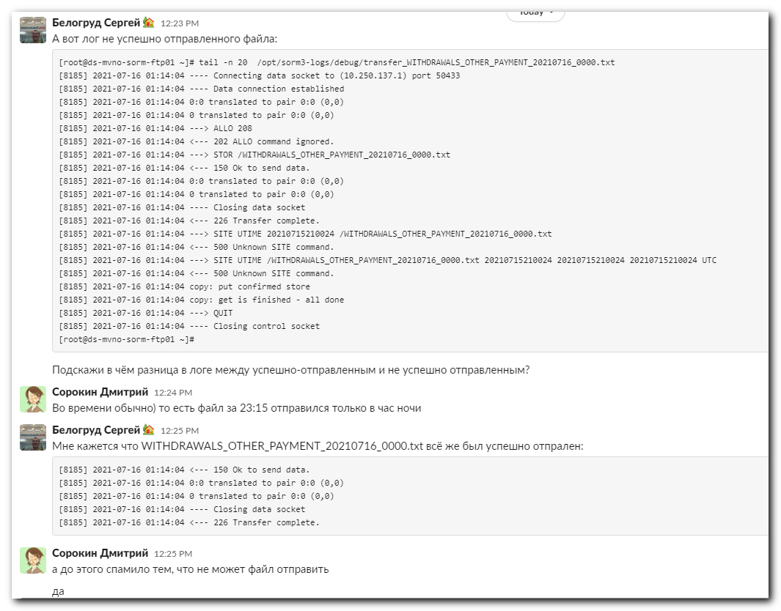
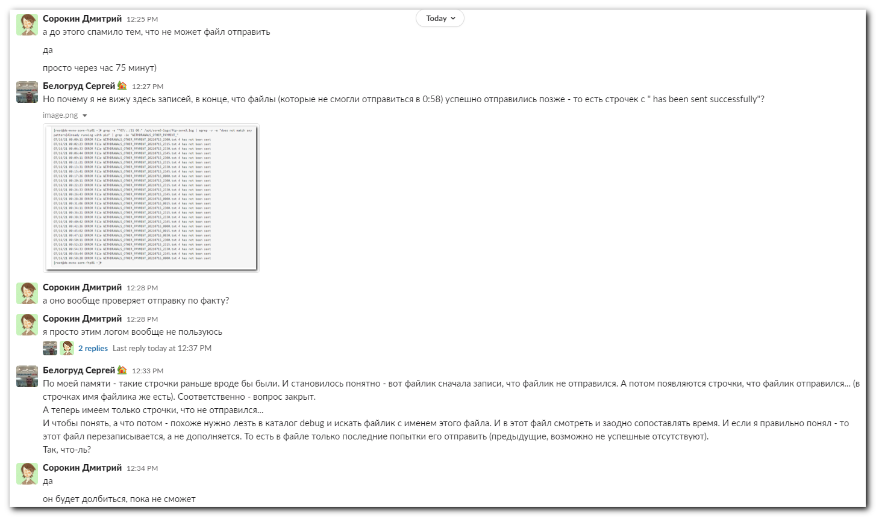
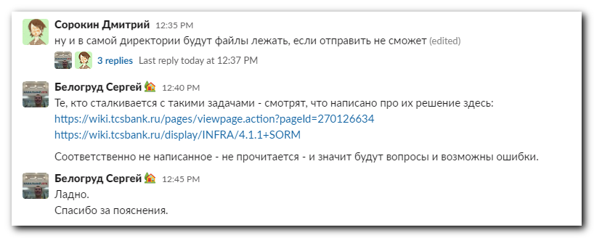

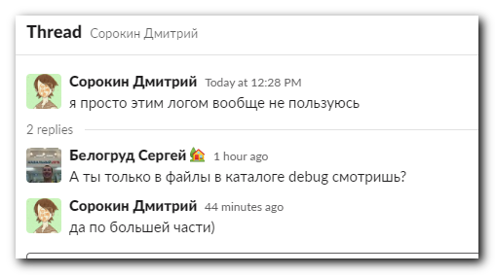
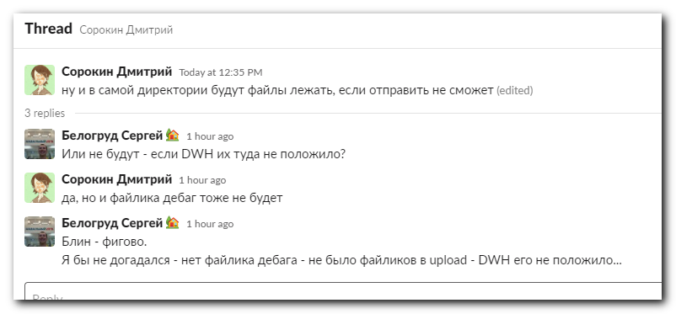

[root@ds-mvno-sorm-ftp01 ~]# grep -e "^07/16/21 00:" /opt/sorm3-logs/ftp-sorm3.log | egrep -v -e "does not match any pattern|Already running with pid" |
grep -ie "WITHDRAWALS_OTHER_PAYMENT_"
07/16/21 00:00:11 ERROR File WITHDRAWALS_OTHER_PAYMENT_20210715_2300.txt 4 has not been sent
07/16/21 00:02:23 ERROR File WITHDRAWALS_OTHER_PAYMENT_20210715_2315.txt 4 has not been sent
07/16/21 00:04:33 ERROR File WITHDRAWALS_OTHER_PAYMENT_20210715_2330.txt 4 has not been sent
07/16/21 00:06:44 ERROR File WITHDRAWALS_OTHER_PAYMENT_20210715_2345.txt 4 has not been sent
07/16/21 00:09:11 ERROR File WITHDRAWALS_OTHER_PAYMENT_20210715_2300.txt 4 has not been sent
07/16/21 00:11:21 ERROR File WITHDRAWALS_OTHER_PAYMENT_20210715_2315.txt 4 has not been sent
07/16/21 00:13:31 ERROR File WITHDRAWALS_OTHER_PAYMENT_20210715_2330.txt 4 has not been sent
07/16/21 00:15:41 ERROR File WITHDRAWALS_OTHER_PAYMENT_20210715_2345.txt 4 has not been sent
07/16/21 00:17:26 ERROR File WITHDRAWALS_OTHER_PAYMENT_20210716_0000.txt 4 has not been sent
07/16/21 00:20:11 ERROR File WITHDRAWALS_OTHER_PAYMENT_20210715_2300.txt 4 has not been sent
07/16/21 00:22:23 ERROR File WITHDRAWALS_OTHER_PAYMENT_20210715_2315.txt 4 has not been sent
07/16/21 00:24:33 ERROR File WITHDRAWALS_OTHER_PAYMENT_20210715_2330.txt 4 has not been sent
07/16/21 00:26:43 ERROR File WITHDRAWALS_OTHER_PAYMENT_20210715_2345.txt 4 has not been sent
07/16/21 00:28:28 ERROR File WITHDRAWALS_OTHER_PAYMENT_20210716_0000.txt 4 has not been sent
07/16/21 00:31:06 ERROR File WITHDRAWALS_OTHER_PAYMENT_20210716_0015.txt 4 has not been sent
07/16/21 00:34:11 ERROR File WITHDRAWALS_OTHER_PAYMENT_20210715_2300.txt 4 has not been sent
07/16/21 00:36:21 ERROR File WITHDRAWALS_OTHER_PAYMENT_20210715_2315.txt 4 has not been sent
07/16/21 00:38:31 ERROR File WITHDRAWALS_OTHER_PAYMENT_20210715_2330.txt 4 has not been sent
07/16/21 00:40:42 ERROR File WITHDRAWALS_OTHER_PAYMENT_20210715_2345.txt 4 has not been sent
07/16/21 00:42:26 ERROR File WITHDRAWALS_OTHER_PAYMENT_20210716_0000.txt 4 has not been sent
07/16/21 00:45:02 ERROR File WITHDRAWALS_OTHER_PAYMENT_20210716_0015.txt 4 has not been sent
07/16/21 00:47:12 ERROR File WITHDRAWALS_OTHER_PAYMENT_20210716_0030.txt 4 has not been sent
07/16/21 00:50:11 ERROR File WITHDRAWALS_OTHER_PAYMENT_20210715_2300.txt 4 has not been sent
07/16/21 00:52:23 ERROR File WITHDRAWALS_OTHER_PAYMENT_20210715_2315.txt 4 has not been sent
07/16/21 00:54:33 ERROR File WITHDRAWALS_OTHER_PAYMENT_20210715_2330.txt 4 has not been sent
07/16/21 00:56:44 ERROR File WITHDRAWALS_OTHER_PAYMENT_20210715_2345.txt 4 has not been sent
07/16/21 00:58:28 ERROR File WITHDRAWALS_OTHER_PAYMENT_20210716_0000.txt 4 has not been sent
[root@ds-mvno-sorm-ftp01 ~]#

[root@ds-mvno-sorm-ftp01 ~]# less /opt/sorm3-logs/debug/transfer_WITHDRAWALS_OTHER_PAYMENT_20210715_0000.txt
[root@ds-mvno-sorm-ftp01 ~]#

[root@ds-mvno-sorm-ftp01 ~]# ls /mnt/sorm_exchange/upload/
[root@ds-mvno-sorm-ftp01 ~]#

[root@ds-mvno-sorm-ftp01 ~]# less /opt/sorm3-logs/ftp-sorm3.log-20210716.gz
...
07/15/21 22:48:42 INFO File PAYMENT_20210715_2245.txt 140 has been sent successfully
07/15/21 22:49:02 INFO File ACCOUNT_BANK_PAYMENT_20210715_2245.txt 4 has been sent successfully
07/15/21 22:49:22 INFO File CONNECTION_AAA_20210715_2245.txt 21560 has been sent successfully
07/15/21 22:49:42 INFO File WITHDRAWALS_OTHER_PAYMENT_20210715_2245.txt 4 has been sent successfully
07/15/21 23:02:27 ERROR File CONNECTION_GSM_20210715_2300.txt 28 has not been sent
07/15/21 23:02:53 ERROR File PAYMENT_20210715_2300.txt 132 has not been sent
07/15/21 23:03:19 ERROR File ACCOUNT_BANK_PAYMENT_20210715_2300.txt 4 has not been sent
07/15/21 23:03:45 ERROR File CONNECTION_AAA_20210715_2300.txt 20592 has not been sent
07/15/21 23:04:11 ERROR File WITHDRAWALS_OTHER_PAYMENT_20210715_2300.txt 4 has not been sent
...

[root@ds-mvno-sorm-ftp01 ~]# less /opt/sorm3-logs/debug/transfer_WITHDRAWALS_OTHER_PAYMENT_20210715_2245.txt
...
[30004] 2021-07-15 22:49:42 <--- 230 Login successful.
[30004] 2021-07-15 22:49:42 ---> PWD
[30004] 2021-07-15 22:49:42 <--- 257 "/"
[30004] 2021-07-15 22:49:42 ---- attempt number 1
[30004] 2021-07-15 22:49:42 ---> TYPE I
[30004] 2021-07-15 22:49:42 <--- 200 Switching to Binary mode.
[30004] 2021-07-15 22:49:42 ---> PASV
[30004] 2021-07-15 22:49:42 <--- 227 Entering Passive Mode (10,250,137,1,197,242).
[30004] 2021-07-15 22:49:42 ---- Connecting data socket to (10.250.137.1) port 50674
[30004] 2021-07-15 22:49:42 ---- Data connection established
[30004] 2021-07-15 22:49:42 0:0 translated to pair 0:0 (0,0)
[30004] 2021-07-15 22:49:42 0 translated to pair 0:0 (0,0)
[30004] 2021-07-15 22:49:42 ---> ALLO 208
[30004] 2021-07-15 22:49:42 <--- 202 ALLO command ignored.
[30004] 2021-07-15 22:49:42 ---> STOR /WITHDRAWALS_OTHER_PAYMENT_20210715_2245.txt
[30004] 2021-07-15 22:49:42 <--- 150 Ok to send data.
[30004] 2021-07-15 22:49:42 0:0 translated to pair 0:0 (0,0)
[30004] 2021-07-15 22:49:42 0 translated to pair 0:0 (0,0)
[30004] 2021-07-15 22:49:42 ---- Closing data socket
[30004] 2021-07-15 22:49:42 <--- 226 Transfer complete.
[30004] 2021-07-15 22:49:42 ---> SITE UTIME 20210715194624 /WITHDRAWALS_OTHER_PAYMENT_20210715_2245.txt
[30004] 2021-07-15 22:49:42 <--- 500 Unknown SITE command.
[30004] 2021-07-15 22:49:42 ---> SITE UTIME /WITHDRAWALS_OTHER_PAYMENT_20210715_2245.txt 20210715194624 20210715194624 20210715194624 UTC
[30004] 2021-07-15 22:49:42 <--- 500 Unknown SITE command.
[30004] 2021-07-15 22:49:42 copy: put confirmed store
[30004] 2021-07-15 22:49:42 copy: get is finished - all done
[30004] 2021-07-15 22:49:42 ---> QUIT
[30004] 2021-07-15 22:49:42 ---- Closing control socket

[root@ds-mvno-sorm-ftp01 ~]# zgrep -e "^07/../21 00:" /opt/sorm3-logs/ftp-sorm3.log-20210716.gz | egrep -v -e "does not match any pattern|Already running with pid" | grep -ie "WITHDRAWALS_OTHER_PAYMENT_"
07/15/21 00:03:21 INFO File WITHDRAWALS_OTHER_PAYMENT_20210715_0000.txt 4 has been sent successfully
07/15/21 00:19:21 INFO File WITHDRAWALS_OTHER_PAYMENT_20210715_0015.txt 4 has been sent successfully
07/15/21 00:33:42 INFO File WITHDRAWALS_OTHER_PAYMENT_20210715_0030.txt 4 has been sent successfully
07/15/21 00:49:42 INFO File WITHDRAWALS_OTHER_PAYMENT_20210715_0045.txt 4 has been sent successfully
[root@ds-mvno-sorm-ftp01 ~]#

[root@ds-mvno-sorm-ftp01 ~]# tail -n 20 /opt/sorm3-logs/debug/transfer_WITHDRAWALS_OTHER_PAYMENT_20210716_0000.txt
[8185] 2021-07-16 01:14:04 ---- Connecting data socket to (10.250.137.1) port 50433
[8185] 2021-07-16 01:14:04 ---- Data connection established
[8185] 2021-07-16 01:14:04 0:0 translated to pair 0:0 (0,0)
[8185] 2021-07-16 01:14:04 0 translated to pair 0:0 (0,0)
[8185] 2021-07-16 01:14:04 ---> ALLO 208
[8185] 2021-07-16 01:14:04 <--- 202 ALLO command ignored.
[8185] 2021-07-16 01:14:04 ---> STOR /WITHDRAWALS_OTHER_PAYMENT_20210716_0000.txt
[8185] 2021-07-16 01:14:04 <--- 150 Ok to send data.
[8185] 2021-07-16 01:14:04 0:0 translated to pair 0:0 (0,0)
[8185] 2021-07-16 01:14:04 0 translated to pair 0:0 (0,0)
[8185] 2021-07-16 01:14:04 ---- Closing data socket
[8185] 2021-07-16 01:14:04 <--- 226 Transfer complete.
[8185] 2021-07-16 01:14:04 ---> SITE UTIME 20210715210024 /WITHDRAWALS_OTHER_PAYMENT_20210716_0000.txt
[8185] 2021-07-16 01:14:04 <--- 500 Unknown SITE command.
[8185] 2021-07-16 01:14:04 ---> SITE UTIME /WITHDRAWALS_OTHER_PAYMENT_20210716_0000.txt 20210715210024 20210715210024 20210715210024 UTC
[8185] 2021-07-16 01:14:04 <--- 500 Unknown SITE command.
[8185] 2021-07-16 01:14:04 copy: put confirmed store
[8185] 2021-07-16 01:14:04 copy: get is finished - all done
[8185] 2021-07-16 01:14:04 ---> QUIT
[8185] 2021-07-16 01:14:04 ---- Closing control socket
[root@ds-mvno-sorm-ftp01 ~]#

